UDL Stepping Stone: Representation + Engagement
NOTE: This Stepping Stone may be seperated into two sessions…Representation and Expression.
We know that Universal Design is all about increasing access and removing barriers. This sounds great, but how exactly can we get started with these ideas? Two places we can consider are thinking about:

- Representation Principle: The useful ways we share information and ideas with our students. Consider Representation the INPUT.

- Expression Principle: The useful ways we can let students create work that shows what they know or are learning. Consider Expression the OUTPUT.

So, Let’s take a look…

1) Watch each video clip.

2) After each clip, use the Connect-Extend-Challenge tool to guide your thinking.
(Great for the classroom, too!)

3) Hold a focused discussion about the benefits of “planning with UDL in Mind.” Use the Connect-Extend-Challenge tool to center the conversation.

These two clips show a teacher provide very simple examples of how teachers can use the Representation principle and the Expression principle, both of which enable students to Engage through choice.

Representation example (4:56)
https://www.youtube.com/watch?v=jU9bzxYQ5PM

Action + Expression example (3:18)
https://www.youtube.com/watch?v=CeMncpr5gRQ

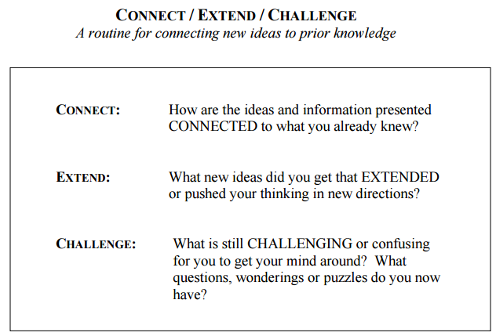
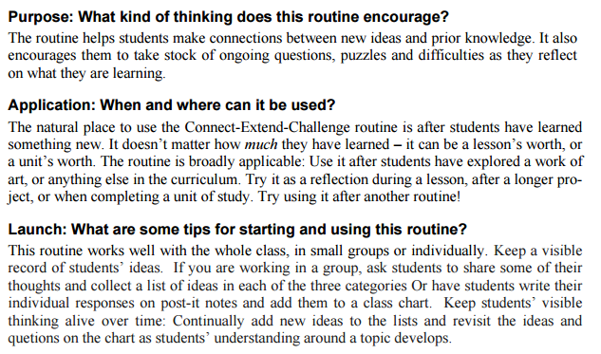
Connect-Extend-Challenge
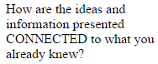
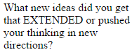
What is still CHALLENGING for you? What questions do you still have about this?

